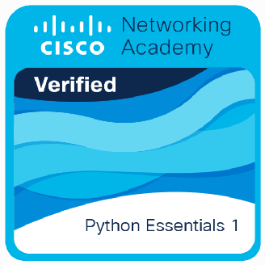
Statement of Achievement

Shashank Ramteke
has successfully achieved student level credential for completing the Python Essentials 1 course, provided by Cisco Networking Academy in collaboration with OpenEDG Python Institute.

The graduate has studied:
- Design, develop, debug, execute, and refactor simple computer programs written in Python 3.
- Think algorithmically to analyze problems and implement them as computer processes.
- Use the syntax, semantics, and the most important elements of the Python Standard Library to write Python scripts and resolve typical implementation challenges.
- Understand the role of a programmer in the software development process.
- Attempt the qualification PCEP - Certified Entry-Level Python Programmer from OpenEDG Python Institute and continue their professional development at an intermediate level with Python Essentials 2.
■


  - .
ii!-] .

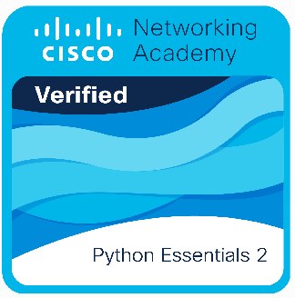
Statement of Achievement

Shashank Ramteke
has successfully achieved student level credential for completing the Python Essentials 2 course, provided by Cisco Networking Academy in collaboration with OpenEDG Python Institute.

The graduate has studied:
- Design, develop, debug, execute, and refactor multi-module computer programs written in Python 3.
- Analyze and model real-life problems in OOP categories.
- Use the potential of Python in everyday applications, including loT and DIY activities.
- Understand the role of a programmer in the software development process.
- Attempt the qualification PCAP - Certified Associate in Python Programming from OpenEDG Python Institute and continue their professional development at an advanced level.


■-·..-�--�
.......
00. • • "'

